SUMMER 1 HOMEWORK PROJECT
We will soon be learning about World War II in class. For your home learning, please choose ONE of the project options. You may need to do a little research before you start. Please ask an adult to help you find safe, age-appropriate information — BBC Bitesize is a great place to look.

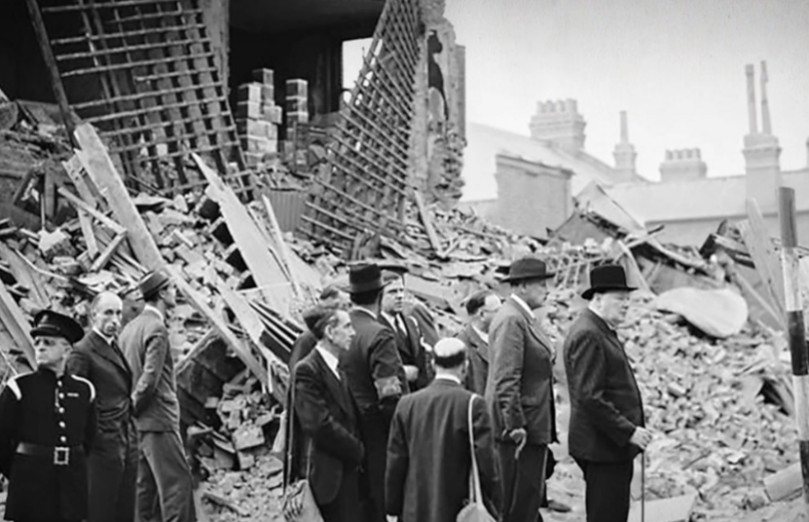
OPTION 1: Blitz Artwork
Create a dramatic piece of artwork showing a scene from the Blitz. Your artwork might show:
- Searchlights in the sky
- Dark building silhouettes
- Flames or smoke
- An air-raid shelter or night-time skyline
OPTION 2: Evacuee Suitcase Artwork
Design a detailed picture or collage of an evacuee’s suitcase. You can draw it, paint it, or create a mixed-media collage. Include:
- The suitcase
- The items a child would pack
- Labels or short notes explaining why each item was important
OPTION 3: Rationing Poster
Create a bright, bold WW2-style poster teaching people how to cope with rationing. Your poster could encourage people to:
- “Dig for Victory”
- Save food
- Make Do and Mend

OTHER HOMEWORK:
- Read 5 times a work for 10 minutes
- Complete TTRS activities
- Practice your weekly spellings
HOMEWORK DUE:
No later than 18th May please!

