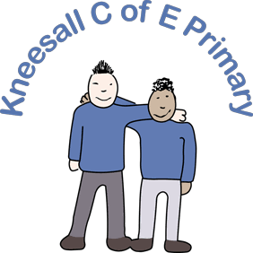
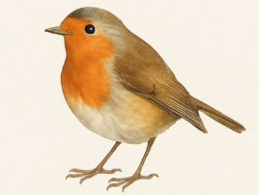
Robins Learning Letter
Autumn 1
Miss Lane

A Warm Welcome

Hello and welcome to Robins Class! My name is Miss Lane, the EYFS class teacher for both reception (Butterflies) and nursery (Caterpillars).

Throughout the summer break, I have very much enjoyed catching up with friends and spending quality time with my family, including visits to Holmfirth, Knaresborough and a week in Kos.

Mrs Richmond, our class teaching assistant has also spent three weeks travelling around Thailand and Vietnam, so we are both well rested and excited to start a new year at Kneesall.

We hope you have also had a wonderful summer break and look forward to hearing all about the children’s adventures as we reconnect with familiar faces and get to know our new starters over the coming days and weeks.

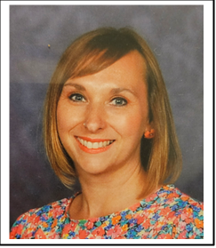

Miss Lane
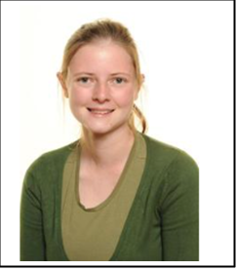

Mrs Richmond

PE
Children will not need to wear PE kit during the autumn term as they will have access to a variety of resources, games and equipment to help them develop physically. Timetabled PE lessons will begin in the spring term.

What are we learning?

This half term, the children will be settling into school life, building relationships and becoming familiar with our rules and routines.

As part of our ‘Marvellous Me’ topic, the children will enjoy discovering more about themselves, including their appearance, body, home life, and feelings, helping them to build confidence and self-awareness.

In RE, the children will learn about the importance of family and community, and how these relationships help us feel cared for, safe, and instil a sense of belonging.
In maths, the Caterpillars will be given opportunities to make collections so they can see and feel different amounts of objects. The Butterflies will start to explore, match, sort and compare pictures and objects.



Phonics
At Kneesall, we teach phonics through the ‘Read Write Inc.’ scheme. The children will meet ‘Fred the frog’ who can only talk in sounds (e.g. c-a-t). With Fred’s help, they will first learn to orally blend words through playing lots of listening games.


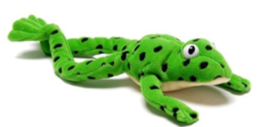
Should you have any questions or concerns, please feel free to speak with me at the gate, and I will do my best to help at that time. For non-urgent matters, it is preferable to catch up after school once the children have been dismissed.

